Experiment no 7

AIM: - To design 1 bit SRAM layout .

OBJECTIVE: - To study design of 1 bit SRAM layout in Microwind and verify the result.
THEORY: -
Figure shows a typical memory organization layout . It consists of a memory array, a row recorder, a column decoder and a read/write circuit. The row decoder selects one row from 2N, because of a N-bit row selection address. The column decoder selects one row from 2M, thanks to a M-bit column selection address. The memory array is based on 2N rows and 2M columns of a repeated pattern, the basic memory cell. A typical value for N and M is 10, leading to 1024 rows and 1024 columns, which corresponds to 1048576 elementary memory cells (1Mega-bit). The basic cell for static memory design is based on 6 transistors, with two pass gates instead of one. The corresponding schematic diagram is given in figure. The circuit consists of the 2 cross-coupled inverters, but uses two pass transistors instead of one.

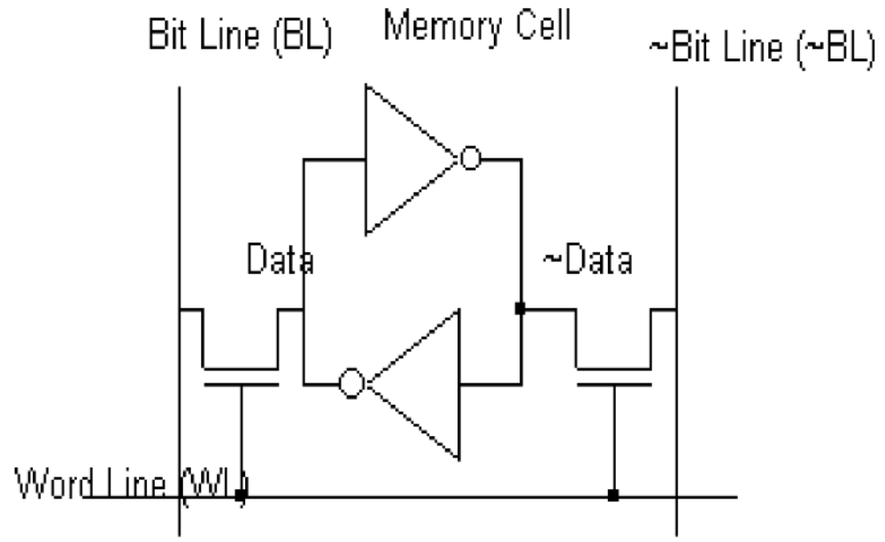

WRITE CYCLE: Values 1 or 0 must be placed on Bit Line, and the data inverted value on ~Bit Line. Then the selection Word Line goes to 1. The two-inverter latch takes the Bit Line value. When the selection Word Line returns to 0, the RAM is in a memory state.

READ CYCLE: The selection signal Word Line must be asserted, but no information should be imposed on the bit lines. In that case, the stored data value propagates to Bit Line, and its inverted value ~Data propagates to ~Bit Line.

SIMULATION: The simulation parameters correspond to the read and write cycle in the RAM. The proposed simulation steps consist in writing a “0”, a “1”, and then reading the “1”. In a second phase, we write a “1”, a “0”, and read the “0”. The Bit Line and ~Bit Line signals are controlled by pulses. The floating state is obtained by inserting the letter "x" instead of 1 or 0 in the description of the signal.

Schematic

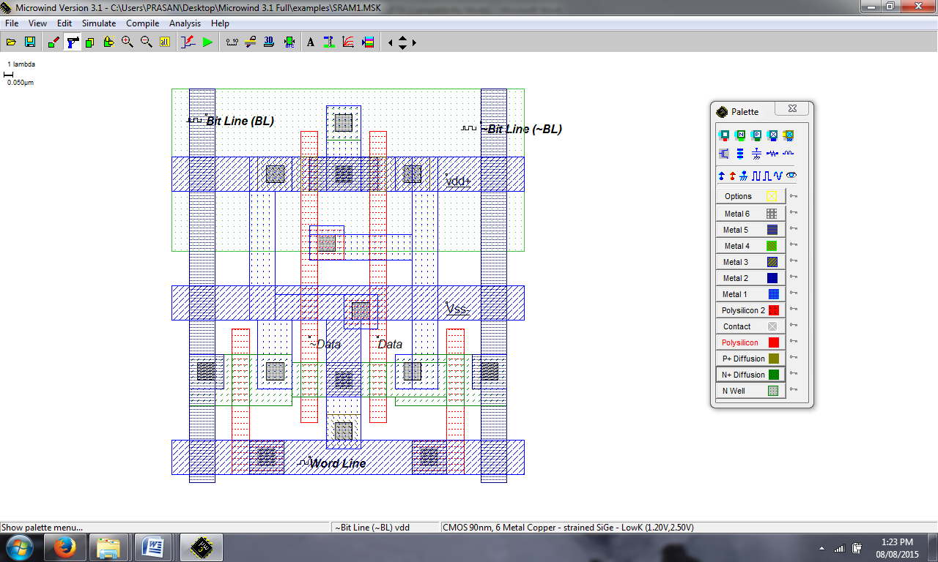
Waveform:
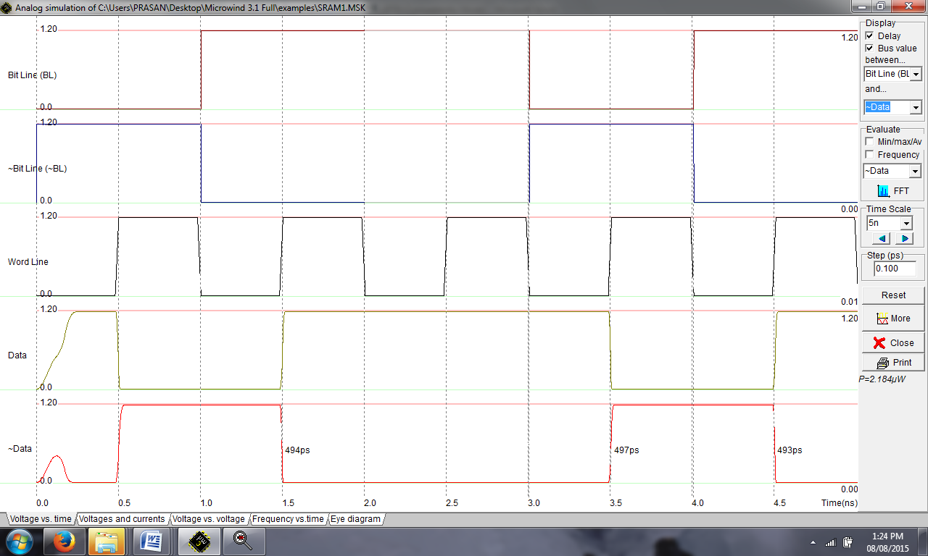
The simulation suggests at time 0.0, Data reaches an unpredictable value of 1, after an unstable period. Meanwhile, ~Data reaches 0. At time 0.5 ns, the memory cell is selected by a 1 on Word Line. As the Bit Line information is 0, the memory cell information Data goes down to 0. At time 1.5 ns, the memory cell is selected again. As the Bit Line information is now 1, the memory cell information Data goes to 1. During the read cycle, in which Bit Line and ~Bit Line signals are floating, the memory sets these wires respectively to 1 and 0, corresponding to the stored values.

Conclusion: -

